Recommend System

In this part of the project, I decided to build a item-item collaborative filtering after seeing that there are much more users than games ( users:18875, games:2554). By doing item-item filtering, I could save massive amount of time.

For building the recommend system, I primarily use Surprise library. After load in the dataset, I extracted the necessary columns to form a new data frame. The data frame is later loaded into Surprise’s module: Dataset. I also set the rating scale to (0, 1) through Reader because I am working with a binary dataset. The dataset is then split into train and test set for encountering overfitting and for evaluation.

The dataset is feed into five different models using cosine similarity. The following is the result:

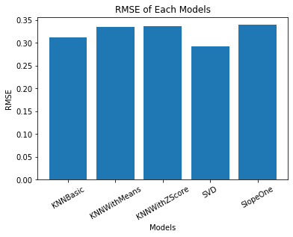

Figure 1. RMSE of Each Models

It is clear that SVD has the lowest RMSE out of the five models thus making the best model to use for the dataset.